
___________________________________________________________________________
BUNION / HALLUX ABDUCTO VALGUS
Hallux abducto valgus, also known as bunion, is described as prominent big toe joint which is often inflamed and painful. The big toe move toward the rest of toes, and big toe joint deviates to the body midline. It is a common foot condition in podiatry.

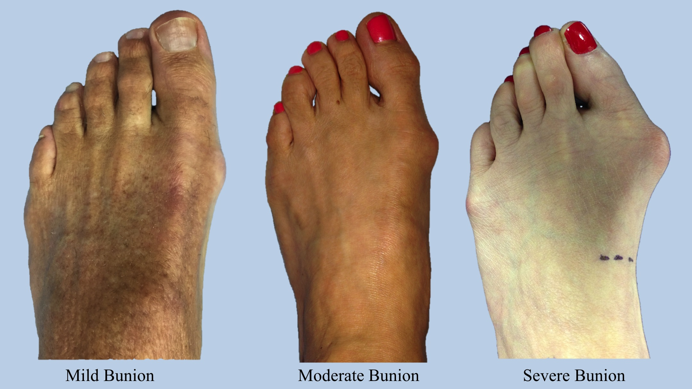
Symptoms include:
Pain, swelling and redness

Risk Factors:
- Family history
- Poor biomechanics (eg, excessive pronation)
- Female
- Poor footwear (eg. tight toe box)
- Muscle imbalance (adductor/abductor halllucis)
- Arthritis

Assessment - The podiatrists at toe-tal will diagnose the condition through a physical examination and biomechanical assessment, and go through all the necessary treatments listed below to help get you on the right path.

Treatment:
- Apply ICE over the painful area for 15 minutes
- Take non-steroidal anti-inflammatory drugs (NSAIDs) for pain, maximum 7 days
- Wear a sandal with arch support (eg. Birkenstocks, orthoheel sandles) instead of thongs and slippers at home
- Wearing the correct socks to reduce bunion pain by reducing the friction by providing cushioning. It is important to choose socks with low friction, so seams over the bunions and cushions over the bunion area from shoe pressure.
- Using a pad (gel or foam) over the bunion deformity
- Using toe separators between 1st and 2nd toes to prevent them rubbing against each other
- A night bunion splint to prevent the 1st and 2nd toe pushing against each other. It won’t fix the bunion but will help to prevent any further progression of it.
- Footwear advice/modification - (talk to the podiatrist at toe-tal about what footwear suits your foot best).
- Orthotic therapy (the podiatrist at toe-tal)
- Bunion surgery

